For user to quick test and enjoy the fun, the Balanbot has almost completely assmebly before shipping, except the acrylic plates and wheels for shipping safe.

So what we need to do is just install those parts and is very simple.

The Balanbot preprogrammed with software, so we can perform a quick test of our Balanbot. But before that we need prepare the 3s lipo-bettery pack, then install the bettery pack into the top of the acrylic paltes, use the magic tape to fix it.

Next, wring the battery connector with the Balanbot.

Everything was ready, lay down the Balanbot on a flat surface, turn on the power switch. After power up, the Balanbot will calibrating the IMU, during this period the Balanbot should not moved in any form. You will hearing a beep if erveything is OK.

OK, we got the Balanbot "beep", then put up the Balanbot vertical and then let go. The Balanbot should balancing well, if not try again, lay down the Balanbot and power off then power on.

Now the Balanbot balancing itself, the testing is OK, next we will use an Android phone to control it.

# ****Assembly****

## ****Prepare****

**Hardware**

* 3s lipo-bettery pack(not including in the kit, you need prepare yourself)
* Balanbot kit

**Software**

* Install the [Android software(apk)](http://duinopeak.com/wiki/index.php?title=%E6%96%87%E4%BB%B6:BalanBotV1.0.0-usb-release.zip) into your Android phone.

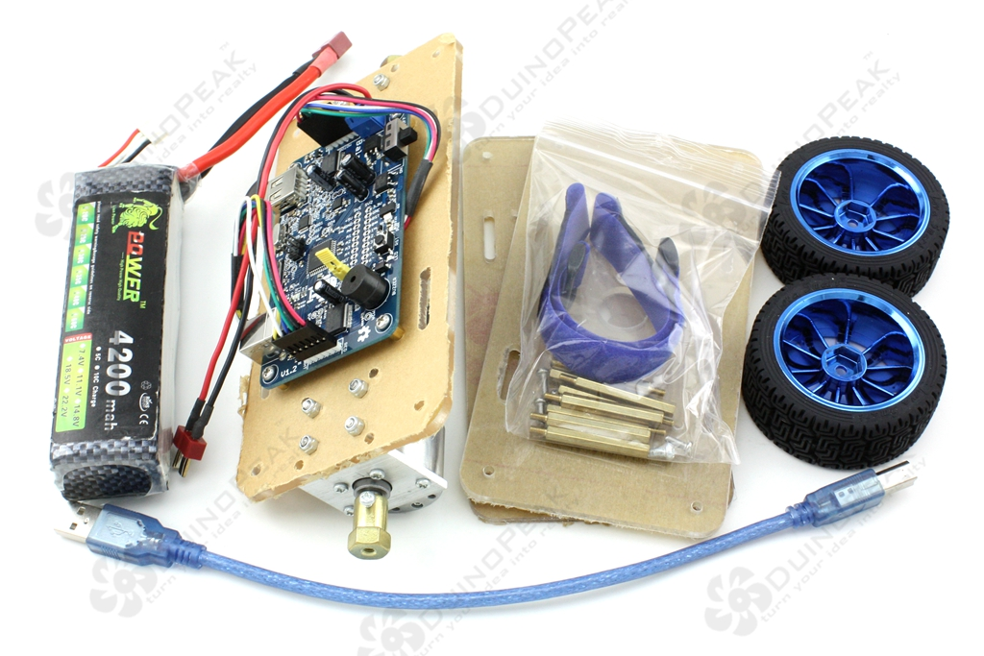

**Note:**

For user to quick test and enjoy the fun of the Robot, the Balanbot has almost completely assmebly before shipping, except the acrylic plates and wheels for shipping safe.

So what we need to do is just install those parts and is very simple.

Now follow the steps to Assembly the Balanbot.

For find the parts clearly, we can list all small parts like below.

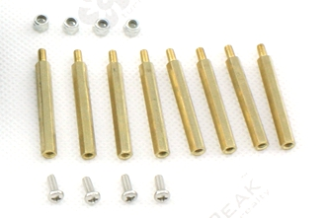

First assembly the first(bottom) layer, use 4 screws to fix the 4 copper pillars, as below:

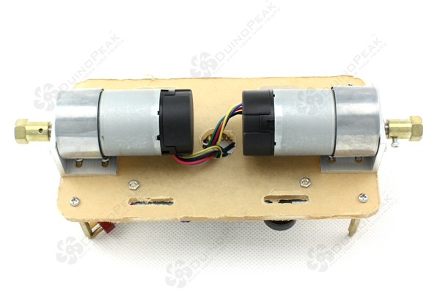

Then stack the second layer acrylic plate on the bottom layer, use another 4 copper pillars to fix the second layer as below:

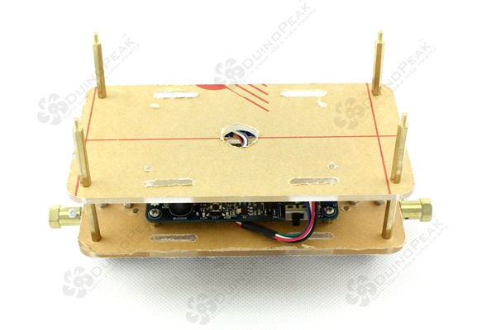

OK, the top layer, before that we better fix the magic tape first. See below image.

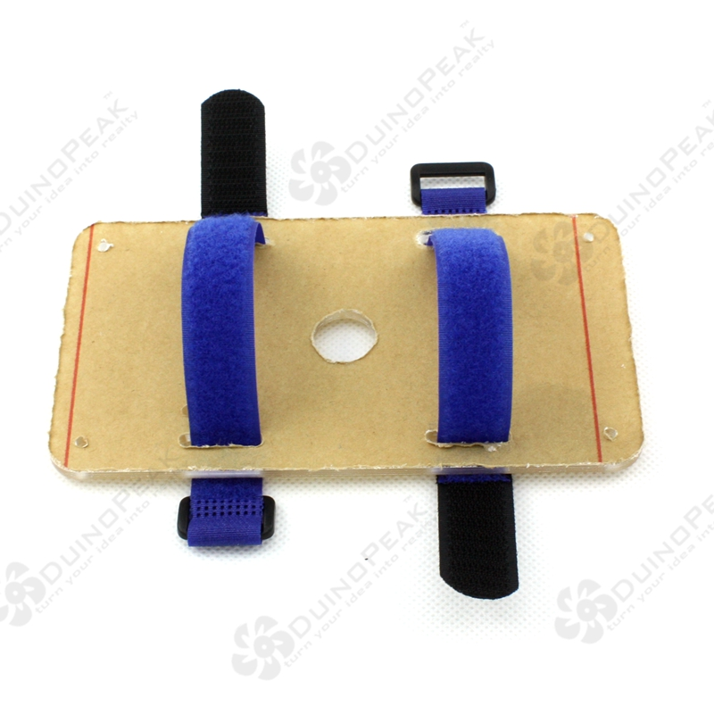

Next put the 3s lipo-bettery pack into the magic tape.

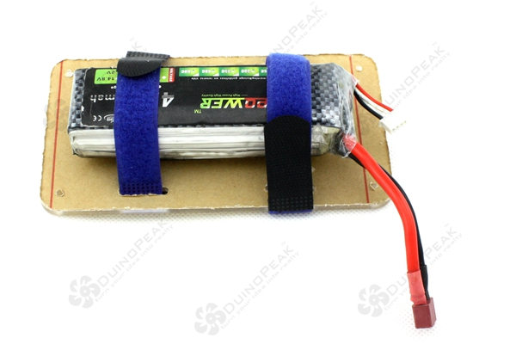

Next step, stack the top layer on the second layer and use for nylon lock nuts to fix the top layer as below.

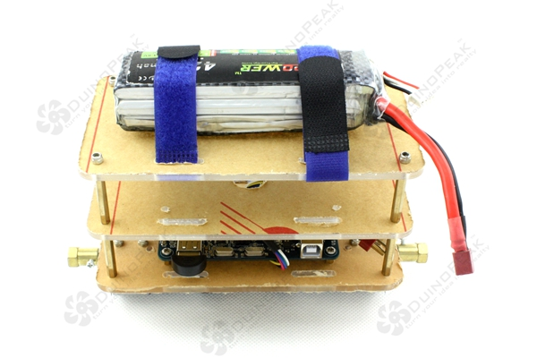

Last step, install the wheels for the Balanbot.



After install the wheels don't forget to screw up the screws. Then plug the Balanbot power plug(male) into battery plug(famale).

Now the assembly has been done, the full assembly Balanbot should be like this.

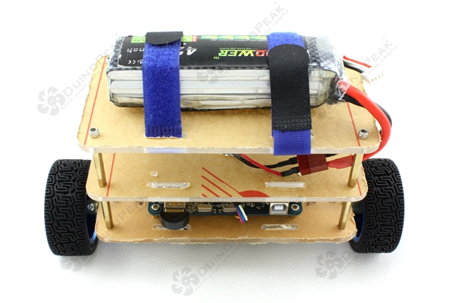

# ****Testing****

The Balanbot preprogrammed with software, so we can perform a quick test of our Balanbot. But before that we need prepare the 3s lipo-bettery pack, then install the bettery pack into the top of the acrylic paltes, use the magic tape to fix it.

Next, wring the battery connector with the Balanbot.

Everything was ready, lay down the Balanbot on a flat surface, turn on the power switch. After power up, the Balanbot will calibrating the IMU, during this period the Balanbot should not moved in any form. You will hearing a beep if erveything is OK.

OK, we got the Balanbot "beep", then put up the Balanbot vertical and then let go. The Balanbot should balancing well, if not try again, lay down the Balanbot and power off then power on.

Now the Balanbot balancing itself, the testing is OK, next we will use an Android phone to control it.

## Remote control

Lay down the Balanbot, do not power off it, make sure the bluetooth dongle inserted in the USB hub and the bluetooth dongle should light up. Open the Balanbot App of your phone.

[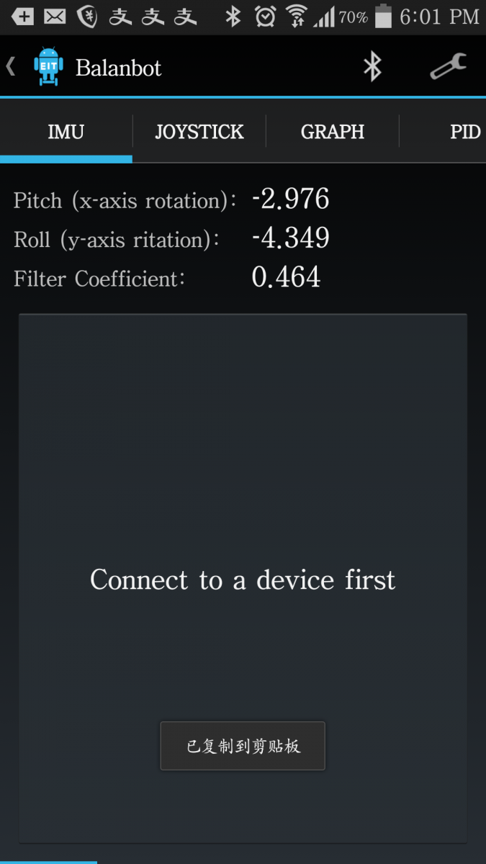](http://www.duinopeak.com/en/sites/default/files/images/robot/balanbot_Android_screenshots_1.png)

Click the bluetooth incon and search, the bluetooth shoul find the device named "Balanbot**", choose and input the paring code:"0000". After connected to the Balanbot you can use didfferent ways to control it.

Also we can adjust the PID and other params of the Balanbot.